ASSIGNMENT WEEK 3

Using ALV, display Header details.

* When double clicked on document-number display item data corresponding to document number.
* Double clicked on payer number in header table. Go to transaction ‘xd03’and skip the first screen and display payer details.
* Double clicked on material number in item table. Go to transaction ‘mm03’and display material details.

1. Header Data can be found in table zsriram_vbrk.
2. Item Data can be found in table zsriram_vbrp.

SOURCE CODE :

*&---------------------------------------------------------------------*  
*& Report ZSRIRAM_ASSIGNMENT_2  
*&---------------------------------------------------------------------*  
*&  
*&---------------------------------------------------------------------*  
REPORT zsriram_assignment_2.  
  
DATA : it_vbrk TYPE STANDARD TABLE OF zsriram_vbrk,  
       it_vbrp TYPE STANDARD TABLE OF zsriram_vbrp.  
  
DATA : lt_fcat TYPE slis_t_fieldcat_alv,  
       lw_fcat LIKE LINE OF lt_fcat.  
  
DATA v_vbeln TYPE vbeln.  
  
SELECT-OPTIONS s_vbeln FOR v_vbeln.  
  
START-OF-SELECTION.  
  PERFORM get_data.  
  
END-OF-SELECTION.  
  PERFORM display.  
*&---------------------------------------------------------------------*  
*& Form get_data  
*&---------------------------------------------------------------------*  
*& text  
*&---------------------------------------------------------------------*  
*& -->  p1        text  
*& <--  p2        text  
*&---------------------------------------------------------------------*  
FORM get_data .  
  SELECT * FROM zsriram_vbrk INTO TABLE it_vbrk WHERE vbeln IN s_vbeln.  
ENDFORM.  
*&---------------------------------------------------------------------*  
*& Form display  
*&---------------------------------------------------------------------*  
*& text  
*&---------------------------------------------------------------------*  
*& -->  p1        text  
*& <--  p2        text  
*&---------------------------------------------------------------------*  
FORM display .  
  
  
  lw_fcat-col_pos = 1.  
  lw_fcat-fieldname = 'VBELN'.  
  lw_fcat-tabname = 'IT_VBRK'.  
  lw_fcat-seltext_m = 'DOCUMENT Number'.  
  lw_fcat-outputlen = 20.  
*  lw_fcat-edit_mask = '==MATN1'.  
  APPEND lw_fcat TO lt_fcat.  
  
  lw_fcat-col_pos = 2.  
  lw_fcat-fieldname = 'FKDAT'.  
  lw_fcat-tabname = 'IT_VBRK'.  
  lw_fcat-seltext_m = 'BILLING DATE'.  
  lw_fcat-outputlen = 30.  
*  lw_fcat-edit_mask = '==ISOLA'.  
  APPEND lw_fcat TO lt_fcat.  
  CLEAR lw_fcat.  
  
  lw_fcat-col_pos = 3.  
  lw_fcat-fieldname = 'KUNRG'.  
  lw_fcat-tabname = 'IT_VBRK'.  
  lw_fcat-seltext_m = 'PAYER'.  
  lw_fcat-outputlen = 40.  
  APPEND lw_fcat TO lt_fcat.  
  
  lw_fcat-col_pos = 4.  
  lw_fcat-fieldname = 'NETWR'.  
  lw_fcat-tabname = 'IT_VBRK'.  
  lw_fcat-seltext_m = 'NET VALUE'.  
  lw_fcat-outputlen = 40.  
  APPEND lw_fcat TO lt_fcat.  
  
  CALL FUNCTION 'REUSE_ALV_GRID_DISPLAY'  
    EXPORTING  
      i_callback_program       = 'ZSRIRAM_ASSIGNMENT_2'  
      i_callback_pf_status_set = 'PF_STATUS'  
      i_callback_user_command  = 'USER_COMMAND'  
      it_fieldcat              = lt_fcat  
    TABLES  
      t_outtab                 = it_VBRK  
    EXCEPTIONS  
      program_error            = 1  
      OTHERS                   = 2.  
  IF sy-subrc <> 0.  
* Implement suitable error handling here  
  ENDIF.  
  
ENDFORM.  
FORM user_command USING r_ucomm LIKE sy-ucomm  
                        rs_selfield TYPE slis_selfield.  
  IF r_ucomm EQ '&IC1' AND rs_selfield-fieldname EQ 'VBELN'.  
  
    SELECT * FROM zsriram_vbrp INTO TABLE it_vbrp WHERE vbeln EQ rs_selfield-value.  
  
    CLEAR lt_fcat.  
    lw_fcat-col_pos = 1.  
    lw_fcat-fieldname = 'POSNR'.  
    lw_fcat-tabname = 'IT_VBRP'.  
    lw_fcat-seltext_m = 'ITEM NUMBER'.  
    lw_fcat-outputlen = 20.  
*    lw_fcat-edit_mask = '==MATN1'.  
    APPEND lw_fcat TO lt_fcat.  
  
    lw_fcat-col_pos = 2.  
    lw_fcat-fieldname = 'MATNR'.  
    lw_fcat-tabname = 'IT_VBRP'.  
    lw_fcat-seltext_m = 'MATERIAL NUMBER'.  
    lw_fcat-outputlen = 30.  
*  lw_fcat-edit_mask = '==ISOLA'.  
    APPEND lw_fcat TO lt_fcat.  
    CLEAR lw_fcat.  
  
    lw_fcat-col_pos = 3.  
    lw_fcat-fieldname = 'FKIMG'.  
    lw_fcat-tabname = 'IT_VBRP'.  
    lw_fcat-seltext_m = 'UON'.  
    lw_fcat-outputlen = 40.  
    APPEND lw_fcat TO lt_fcat.  
  
    lw_fcat-col_pos = 4.  
    lw_fcat-fieldname = 'NETWR'.  
    lw_fcat-tabname = 'IT_VBRP'.  
    lw_fcat-seltext_m = 'NET VALUE'.  
    lw_fcat-outputlen = 40.  
    APPEND lw_fcat TO lt_fcat.  
  
    CALL FUNCTION 'REUSE_ALV_GRID_DISPLAY'  
      EXPORTING  
        i_callback_program       = 'ZSRIRAM_ASSIGNMENT_2'  
        i_callback_pf_status_set = 'PF_STATUS'  
        i_callback_user_command  = 'USER_COMMAND'  
        it_fieldcat              = lt_fcat  
      TABLES  
        t_outtab                 = it_vbrp  
      EXCEPTIONS  
        program_error            = 1  
        OTHERS                   = 2.  
    IF sy-subrc <> 0.  
* Implement suitable error handling here  
    ENDIF.  
  ENDIF.  
  IF r_ucomm EQ '&IC1' AND rs_selfield-fieldname EQ 'MATNR'.  
    SET PARAMETER ID 'MAT' FIELD rs_selfield-value.  
    CALL TRANSACTION 'MM03'.  
  ENDIF.  
  
  IF r_ucomm EQ '&IC1' AND rs_selfield-fieldname EQ 'KUNRG'.  
    SET PARAMETER ID 'KUN' FIELD rs_selfield-value.  
    CALL TRANSACTION 'XD03' AND SKIP FIRST SCREEN.  
  ENDIF.  
ENDFORM.  
  
FORM pf_status USING rt_extab TYPE slis_t_extab.  
  SET PF-STATUS 'STANDARD_FULLSCREEN1'.  
ENDFORM.

1. **Header Data**

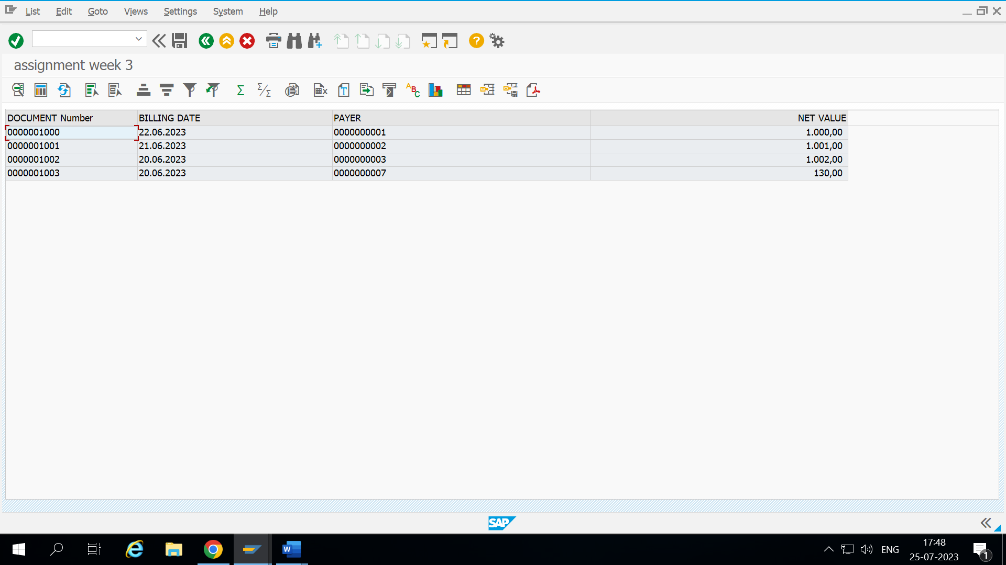

1. **Item Data**

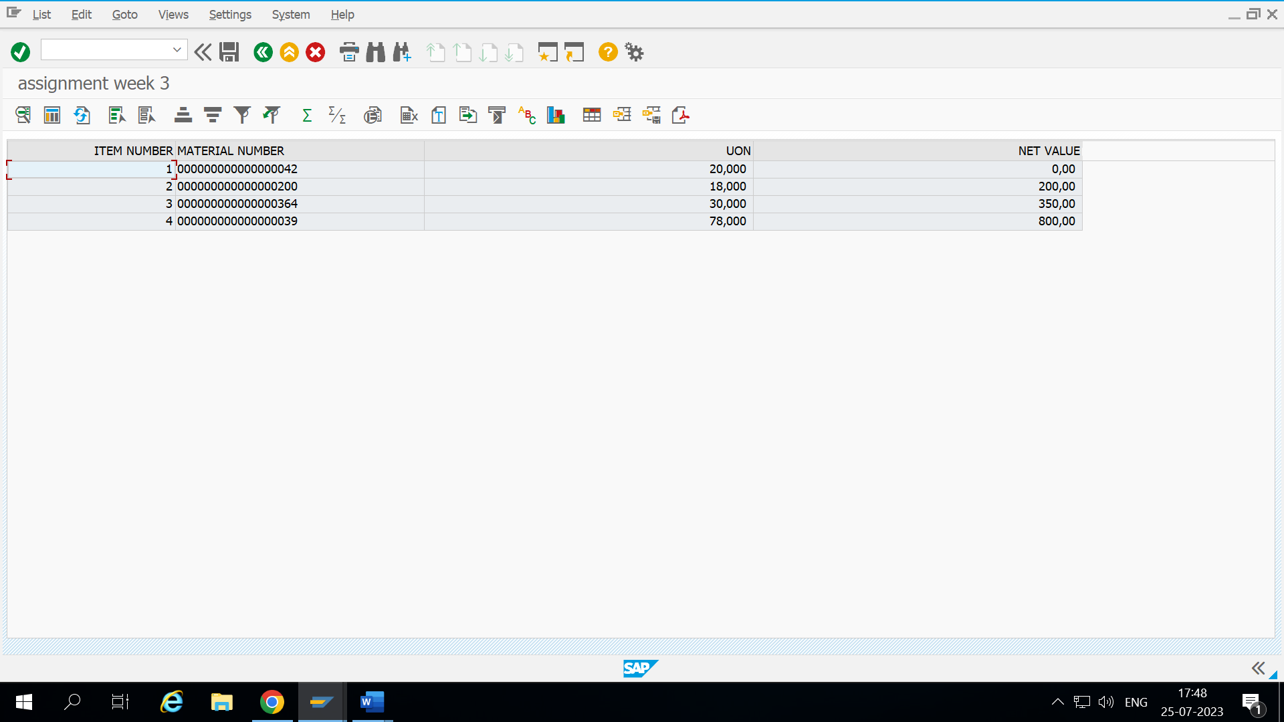

1. **Material Input**

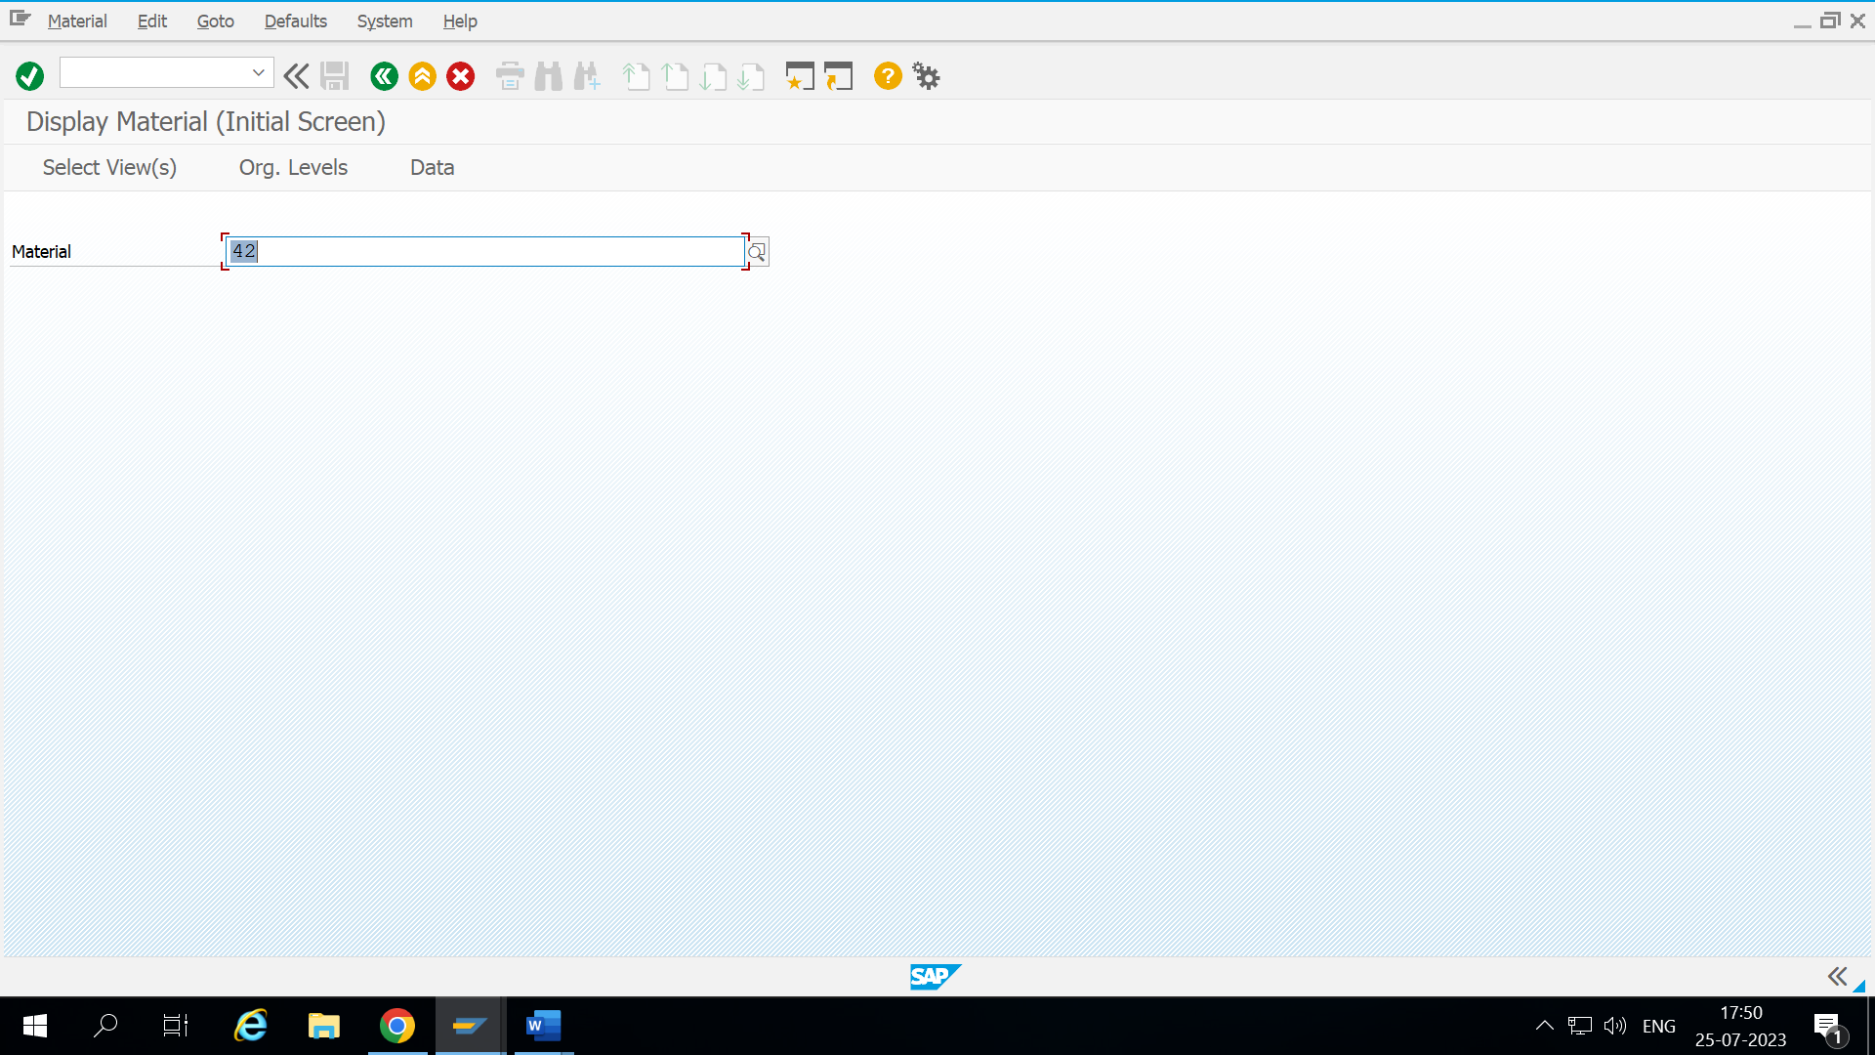

1. **Material Items (Transaction code MM03)**

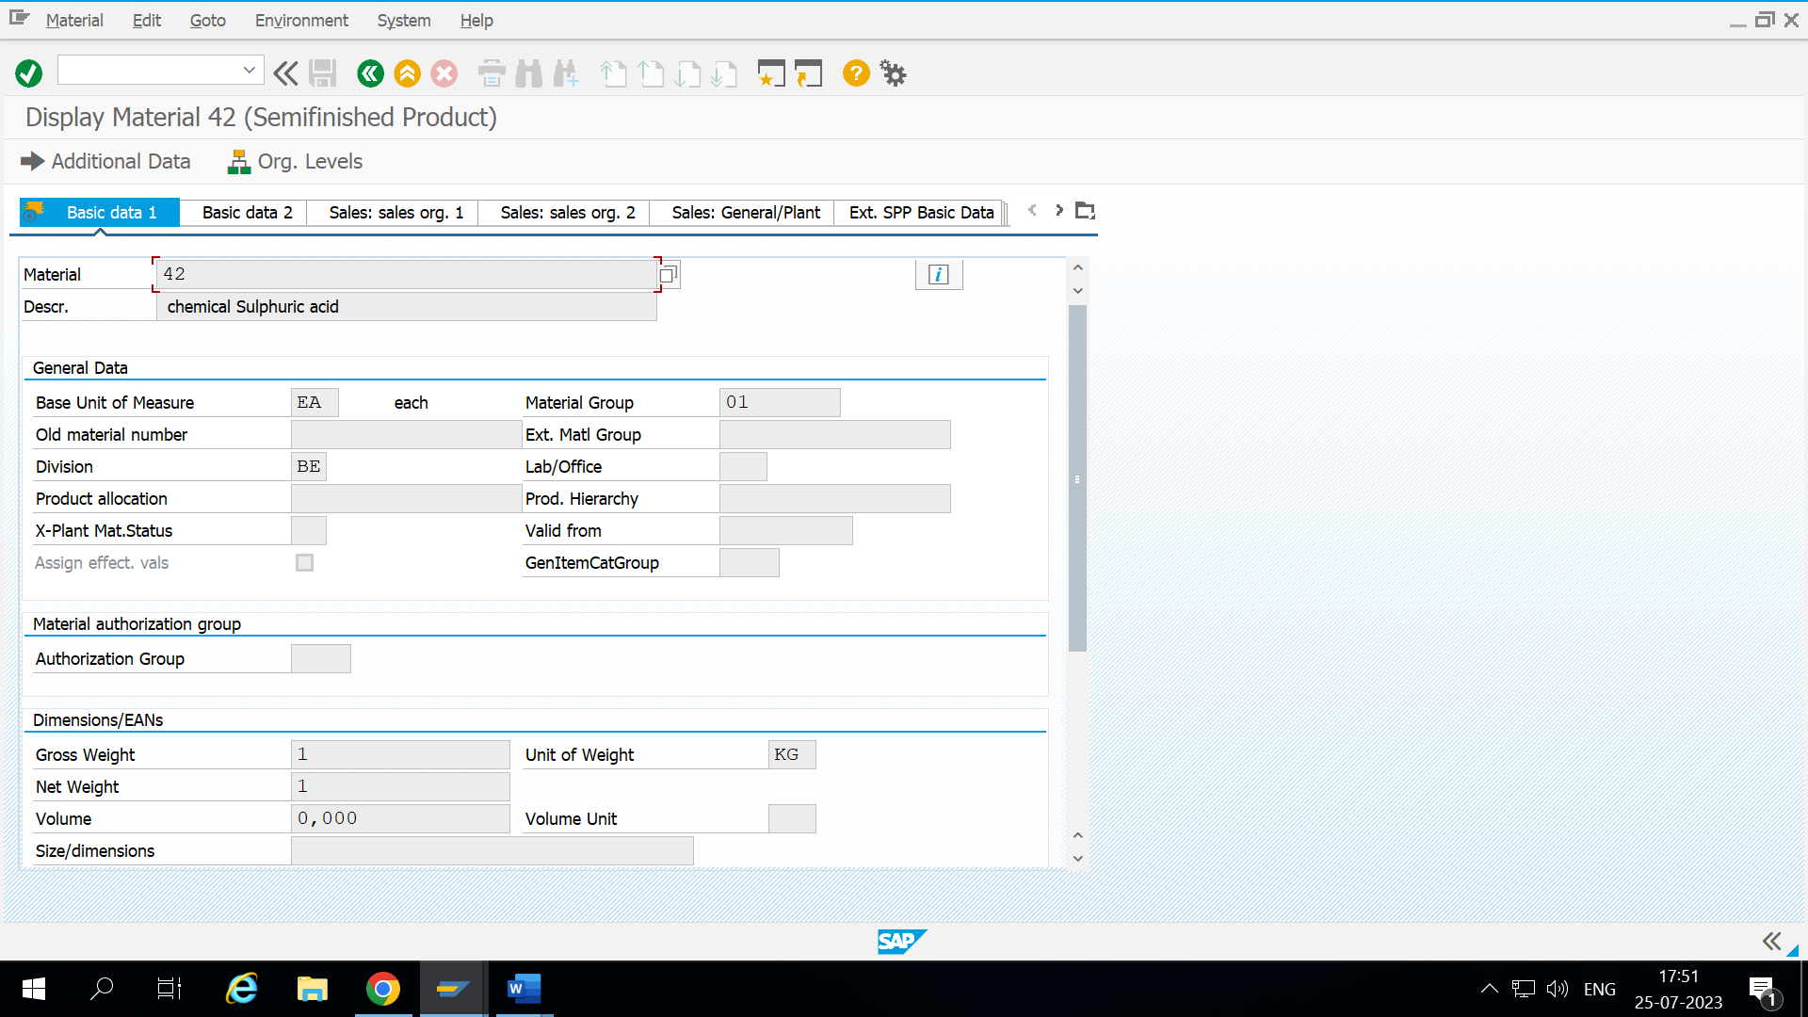

1. **Payer Details (Transaction code XD03)**

